1. Knowing the circuit in the figure 1, having a symmetrical supply of voltages u10, u20, u30, with V, , , determine the currents in the phases and verify the results with power balance.

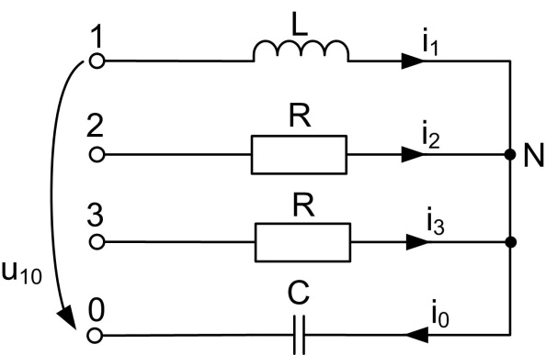

**Fig.** 1

The supply voltages are:

$${\underline{\text{U}}}_{\text{10}}={\text{U}}_{\text{10}}e^{j0}=200;$$

$${\underline{\text{U}}}_{\text{20}}= {\underline{\text{U}}}_{\text{10}}e^{-j\frac{2π}{3}}=200 (-\frac{1}{2}-j\frac{\sqrt{3}}{2}) ;$$

$${\underline{\text{U}}}_{\text{30}}= {\underline{\text{U}}}_{\text{10}}e^{-j\frac{4π}{3}}={\underline{\text{U}}}_{\text{10}}e^{j\frac{2π}{3}}=200 (-\frac{1}{2}+j\frac{\sqrt{3}}{2}) .$$

${\underline{\text{Z}}}_{\text{1}}\text{=}\text{j}\text{ω}\text{L}\text{=}\text{2}\text{0}\text{j}\text{;}$ ${\underline{\text{Z}}}_{\text{2}}={\underline{\text{Z}}}_{\text{3}}\text{=}\text{R}\text{=}\text{2}\text{0}\text{ ;}$

$${\underline{\text{Z}}}_{\text{0}}\text{=}\frac{1}{jωC}=\frac{20}{3j}.$$

The load is unbalanced and we compute the voltage drop on the neutral conductor:

$${\underline{\text{U}}}_{\text{N0}}\text{=}\frac{{\underline{\text{Y}}}_{\text{1}} {\underline{\text{U}}}_{\text{10}}+{\underline{\text{Y}}}_{\text{2}} {\underline{\text{U}}}_{\text{20}}+{\underline{\text{Y}}}_{\text{3}} {\underline{\text{U}}}_{\text{30}}}{{\underline{\text{Y}}}_{\text{1}}+{\underline{\text{Y}}}_{\text{2}}+{\underline{\text{Y}}}_{\text{3}}+{\underline{\text{Y}}}_{\text{0}}}$$

$${\underline{\text{Y}}}_{\text{1}}\text{=}\frac{1}{{\underline{\text{Z}}}_{\text{1}}}=\frac{1}{20j}=-\frac{j}{20}; {\underline{\text{Y}}}_{\text{2}}\text{=} {\underline{\text{Y}}}_{\text{3}}\text{=}\frac{1}{{\underline{\text{Z}}}_{\text{2}}}=\frac{1}{20}; {\underline{\text{Y}}}_{\text{0}}\text{=}\frac{1}{{\underline{\text{Z}}}_{\text{0}}}=\frac{3j}{20}.$$

$${\underline{\text{U}}}_{\text{N}\text{0}}=-\text{100.}$$

$${\underline{\text{I}}}_{\text{1}}\text{=}\frac{{\underline{\text{U}}}_{\text{10}}-{\underline{\text{U}}}_{\text{N0}}}{{\underline{\text{Z}}}_{\text{1}}}={\underline{\text{Y}}}_{\text{1}} \left({\underline{\text{U}}}_{\text{10}}-{\underline{\text{U}}}_{\text{N0}}\right)=-\frac{j}{20} \left(200+100\right)=-15j$$

$${\underline{\text{I}}}_{\text{2}}\text{=}\frac{{\underline{\text{U}}}_{\text{20}}-{\underline{\text{U}}}_{\text{N0}}}{{\underline{\text{Z}}}_{\text{2}}}={\underline{\text{Y}}}_{\text{2}} \left({\underline{\text{U}}}_{\text{20}}-{\underline{\text{U}}}_{\text{N0}}\right)=\frac{1}{20}\left[200 \left(-\frac{1}{2}-j\frac{\sqrt{3}}{2}\right)+100\right]==10\left(-\frac{1}{2}-j\frac{\sqrt{3}}{2}\right)+5=-5\sqrt{3}j$$

$${\underline{\text{I}}}_{\text{3}}\text{=}\frac{{\underline{\text{U}}}_{\text{30}}-{\underline{\text{U}}}_{\text{N0}}}{{\underline{\text{Z}}}_{\text{3}}}={\underline{\text{Y}}}_{\text{3}} \left({\underline{\text{U}}}_{\text{30}}-{\underline{\text{U}}}_{\text{N0}}\right)=\frac{1}{20} \left[200 \left(-\frac{1}{2}+j\frac{\sqrt{3}}{2}\right)+100\right]==10\left(-\frac{1}{2}+j\frac{\sqrt{3}}{2}\right)+5=5\sqrt{3}j$$

$${\underline{\text{I}}}_{\text{0}}=\frac{{\underline{\text{U}}}_{\text{N0}}}{{\underline{\text{Z}}}_{\text{0}}}= {\underline{\text{Y}}}_{\text{0}}{\underline{\text{U}}}_{\text{N0}}=\frac{3j}{20}∙\left(-100\right)=-15j .$$

*We cand verify the current thru the neutral conductor with the relation:*

$${\underline{\text{I}}}_{\text{0}}={\underline{\text{I}}}_{\text{1}}+{\underline{\text{I}}}_{\text{2}}+{\underline{\text{I}}}_{\text{3}}=-15j-5\sqrt{3}+5\sqrt{3}j=-15j$$

Then we transform the complex currents into instantanous ones:

$${\text{ r}}_{\text{1}}\text{=}{\text{ I}}_{\text{1}}\text{=}\left|{\underline{\text{I}}}_{\text{1}}\right|=\sqrt{{\text{a}}_{\text{1}}^{\text{2}}\text{+}{\text{b}}_{\text{1}}^{\text{2}}}\text{=}\sqrt{0+{15}^{2}}\text{=}\text{15}$$

$$\left\{\begin{aligned}\text{co}\text{s}{ α}_{1}\text{=}\text{0;} \\ \text{sin}α_{1}\text{=}\text{-}\text{1 . }\end{aligned}\text{→}{ α}_{1}\text{=}-\frac{\text{π}}{\text{2}}\text{.}\right.$$

$${\text{i}}_{\text{1}}\text{=}{\text{i}}_{\text{0}}\text{=}\sqrt{\text{2}}\left|{\underline{\text{I}}}_{\text{1}}\right|\text{sin}\left(\text{ω}\text{t}\text{+}α_{1}\right)\text{=}\text{15}\sqrt{\text{2}}\text{sin}{\text{(}\text{ω}\text{t}}-\frac{\text{π}}{\text{2}}\text{)}$$

$${\text{ r}}_{\text{2}}\text{=}{\text{ I}}_{\text{2}}\text{=}\left|{\underline{\text{I}}}_{\text{2}}\right|=\sqrt{{\text{a}}_{\text{2}}^{\text{2}}\text{+}{\text{b}}_{\text{2}}^{\text{2}}}\text{=}\sqrt{\text{0}+({-5\sqrt{3})}^{2}}\text{=}\text{5}\sqrt{3}$$

$$\left\{\begin{aligned}\text{cos} α_{2}\text{=}\text{0;} \\ \text{sin} α_{2}\text{=}\text{-1 . }\end{aligned}\text{→}{ α}_{2}\text{=}-\frac{\text{π}}{\text{2}}\text{.}\right.$$

$${\text{i}}_{\text{2}}\text{=}\sqrt{\text{2}}\left|{\underline{\text{I}}}_{\text{2}}\right|\text{sin}\left(\text{ω}\text{t}\text{+}α_{2}\right)\text{=}\text{5}\sqrt{\text{3} }\sqrt{\text{2}} \text{sin}{\text{(}\text{ω}\text{t}}-\frac{\text{π}}{\text{2}}\text{) }\text{=}\text{5}\sqrt{\text{6 }} \text{sin}{\text{(}\text{ω}\text{t}}-\frac{\text{π}}{\text{2}}\text{) }\text{.}$$

$${\text{i}}_{\text{3}}\text{=}\sqrt{\text{2}}\left|{\underline{\text{I}}}_{\text{3}}\right|\text{sin}\left(\text{ω}\text{t}\text{+}α_{3}\right)\text{=}\text{5}\sqrt{\text{6}}\text{sin}{\text{(}\text{ω}\text{t}}+\frac{\text{π}}{\text{2}}\text{) }\text{.}$$

Power balance

$${\underline{\text{S}}}_{\text{G}}\text{=} { \underline{\text{U}}}_{\text{10}}\text{∙}{\underline{\text{I}}}_{\text{1}}^{\text{*}}\text{+}{ \underline{\text{U}}}_{\text{20}}\text{∙}{\underline{\text{I}}}_{\text{2}}^{\text{*}}\text{+}{ \underline{\text{U}}}_{\text{30}}\text{∙}{\underline{\text{I}}}_{\text{3}}^{\text{*}}\text{=}\text{200}\text{∙}\text{15j}\text{+}$$

$$\text{200}\left(-\frac{1}{2}-j\frac{\sqrt{3}}{2}\right)\left(5\sqrt{3}j\right)+200 \left(-\frac{1}{2}+j\frac{\sqrt{3}}{2}\right)\left(-5\sqrt{3}j\right)=3000+3000j={\text{P}}_{\text{G}}+j{\text{Q}}_{\text{G}}$$

$${\text{P}}_{\text{G}}\text{=}\text{3000} \text{W;} {\text{Q}}_{\text{G}}\text{=300}0\text{ VAr.}$$

The absorbed powers are:

$${\text{P}}_{\text{Z}}\text{=}\text{R}∙I_{2}^{2}\text{+}\text{R}\text{∙}I_{3}^{2}\text{=}\text{20}\text{∙}{(5\sqrt{3})}^{2}\text{+}\text{20}\text{∙}{(5\sqrt{3})}^{2}\text{=}\text{1500}\text{+}\text{1500}\text{=}\text{3000} \text{W.}$$

$${\text{Q}}_{\text{Z}}\text{=} \text{ω}\text{L}\text{∙}I_{1}^{2}-\frac{1}{ωC}I_{0}^{2}\text{=}\text{20}\text{∙}{\text{15}}^{2}-\frac{\text{20}}{\text{3}}\text{∙}{\text{15}}^{2}\text{=}\text{ 4500}-\text{1500}\text{=}\text{300}0\text{ VAr}.$$

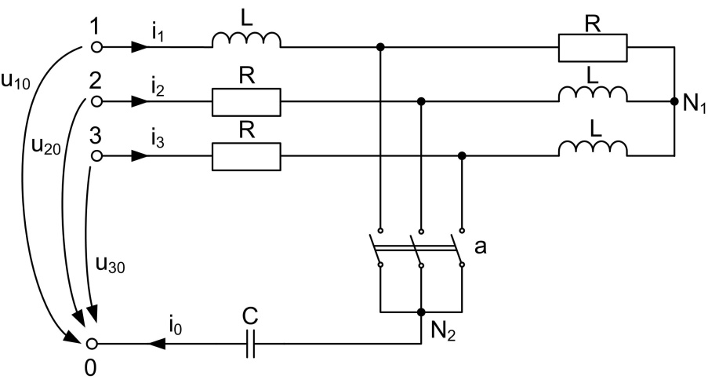

**Fig.** 2a

1. Knowing the circuit in figure 2a feeded with a symmetrical system of voltages u10, u2o, u30, with 10Ω, $\frac{1}{ωC}=\frac{10}{3}$ compute the instaneous values of the currents and verify with power balace for the switch k open and closed.

$${\underline{\text{U}}}_{\text{10}}={\text{U}}_{\text{10}}e^{j\frac{π}{2}}=200 e^{j\frac{π}{2}}=200 \left(cos\frac{π}{2}+jsin\frac{π}{2}\right)=20\text{0j}$$

$${\underline{\text{U}}}_{\text{20}}={\underline{\text{U}}}_{\text{10}}e^{- j\frac{2π}{3}}=200 j{ e}^{- j\frac{2π}{3}}=200 j{ a}^{2}=200j\left(-\frac{1}{2}-j\frac{\sqrt{3}}{2}\right)==10\text{0}\text{j }\left(-1-j\sqrt{3}\right)=100(\sqrt{3}-j)$$

$${\underline{\text{U}}}_{\text{30}}={\underline{\text{U}}}_{\text{10}}e^{ j\frac{2π}{3}}=200 j{ e}^{ j\frac{2π}{3}}=200 j a=200j\left(-\frac{1}{2}+j\frac{\sqrt{3}}{2}\right)==10\text{0}\text{j }\left(-1+j\sqrt{3}\right)=100 (-\sqrt{3}-j)$$

**For k open**

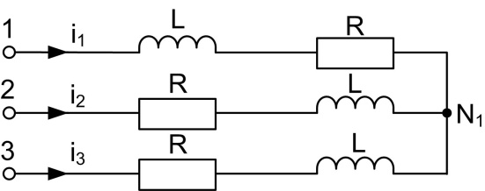

**Fig.** 2b

${\underline{\text{Z}}}_{\text{1}}\text{=} {\underline{\text{Z}}}_{\text{2}}\text{=}{\underline{\text{Z}}}_{\text{3}}\text{=}\text{R}\text{+}\text{j}\text{ω}\text{L}\text{=}\text{1}\text{0+}\text{10}\text{j}$

We have a balanced load. We can compute the current only for the first phase, because the system of currents is a symmetrical one too.

$${\underline{\text{I}}}_{\text{1}}\text{=}\frac{{\underline{\text{U}}}_{\text{10}}}{{\underline{\text{Z}}}_{\text{1}}}=\frac{200j}{\text{10}\text{+}\text{10j}}=\frac{20j}{\text{1}\text{+}\text{j}}\text{=}\frac{20j(\text{1-j}\text{)}}{\text{(}\text{1}\text{+}\text{j}\text{)}(\text{1-j}\text{)}}\text{=}\text{10(1}\text{+}\text{j)}$$

$${\text{ r}}_{\text{1}}\text{=}{\text{ I}}_{\text{1}}\text{=}\left|{\underline{\text{I}}}_{\text{1}}\right|=\sqrt{{\text{a}}_{\text{1}}^{\text{2}}\text{+}{\text{b}}_{\text{1}}^{\text{2}}}\text{=}\sqrt{{10}^{2}+{10}^{2}}\text{=10}\sqrt{\text{2}}$$

$$\left\{\begin{aligned}\text{co}\text{s}{ α}_{1}\text{=}\frac{\sqrt{\text{2}}}{2}\text{;} \\ \text{sin} α_{1}\text{=}\frac{\sqrt{\text{2}}}{2}\text{ . }\end{aligned}\text{→}{ α}_{1}\text{=}\frac{\text{π}}{\text{4}}\text{.}\right.$$

$${\text{i}}_{\text{1}}\text{=}\sqrt{\text{2}}\left|{\underline{\text{I}}}_{\text{1}}\right|\text{sin}\left(\text{ω}\text{t}\text{+}α_{1}\right)\text{=}\text{10}\sqrt{\text{2}}∙\sqrt{\text{2}}\text{sin}{\text{(}\text{ω}\text{t}}+\frac{\text{π}}{\text{4}}\text{)}\text{=}\text{20}\text{sin}{\text{(}\text{ω}\text{t}}+\frac{\text{π}}{\text{4}}\text{)}$$

$${\text{i}}_{\text{2}}\text{=}\text{20}\text{sin}{\text{(}\text{ω}\text{t}}+\frac{\text{π}}{\text{4}}-\frac{\text{2π}}{\text{3}})=\text{20}\text{sin}{\text{(}\text{ω}\text{t}}-\frac{\text{5}\text{π}}{\text{12}})$$

$${\text{i}}_{\text{3}}\text{=}\text{20}\text{sin}{\text{(}\text{ω}\text{t}}+\frac{\text{π}}{\text{4}}-\frac{\text{4π}}{\text{3}}=\text{20}\text{sin}{\text{(}\text{ω}\text{t}}+\frac{\text{π}}{\text{4}}+\frac{\text{2π}}{\text{3}})=\text{20}\text{sin}{\text{(}\text{ω}\text{t}}+\frac{\text{11π}}{\text{12}})$$

Because the system of the currents is a symmetrical one, the current thru the neutral conductor is zero, i0=0.

**Power balance**

$${\underline{\text{S}}}_{\text{G}}\text{=} { 3 \underline{\text{U}}}_{\text{10}}\text{∙}{\underline{\text{I}}}_{\text{1}}^{\text{*}}=3∙\text{200}\text{j}∙10\left(1-j\right)=\text{6000}+\text{6000}j={\text{P}}_{\text{G}}+j{\text{Q}}_{\text{G}}$$

$${\text{P}}_{\text{G}}\text{=}\text{6000} \text{W;} {\text{Q}}_{\text{G}}\text{=}\text{6000} \text{VAr.}$$

Absorbed powers:

$${\text{P}}_{\text{a}}\text{=}\text{3 R}∙I_{\text{1}}^{\text{ 2}}\text{=}\text{3 }\text{∙}\text{10}\text{∙}{\text{(}\text{10}\sqrt{\text{2}}\text{)}}^{2} \text{=}\text{6000 W.}$$

$${\text{Q}}_{\text{a}}\text{=}\text{3}\text{∙} \text{ω}\text{L}\text{∙}I_{\text{1}}^{\text{ 2}}\text{=}\text{3 }\text{∙}\text{10}\text{∙}{\text{(}\text{10}\sqrt{\text{2}}\text{)}}^{2} \text{=}\text{6000 VAr}.$$

**For K closed**

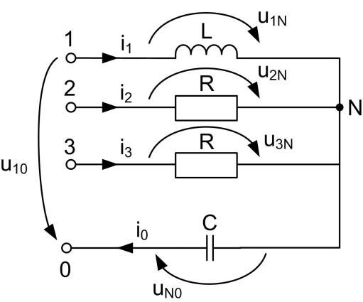

**Fig.** 2c

${\underline{\text{Z}}}_{\text{1}}\text{=}\text{R}\text{=}\text{10}$ ${\underline{\text{Z}}}_{\text{2}}\text{=}{\underline{\text{Z}}}_{\text{3}}\text{=} \text{j}\text{ω}\text{L}\text{=}\text{10}\text{j}$

$${\underline{\text{Z}}}_{\text{0}}\text{=}\frac{1}{jωC}=\frac{10}{3j}=-\frac{10j}{3}$$

We have an unbalanced load, then:

$${\underline{\text{U}}}_{\text{N0}}\text{=}\frac{{\underline{\text{Y}}}_{\text{1}} {\underline{\text{U}}}_{\text{10}}+{\underline{\text{Y}}}_{\text{2}} {\underline{\text{U}}}_{\text{20}}+{\underline{\text{Y}}}_{\text{3}} {\underline{\text{U}}}_{\text{30}}}{{\underline{\text{Y}}}_{\text{1}}+{\underline{\text{Y}}}_{\text{2}}+{\underline{\text{Y}}}_{\text{3}}+{\underline{\text{Y}}}_{\text{0}}},$$

Where:

$${\underline{\text{Y}}}_{\text{1}}\text{=}\frac{1}{{\underline{\text{Z}}}_{\text{1}}}=\frac{1}{10}; {\underline{\text{Y}}}_{\text{2}}\text{=} {\underline{\text{Y}}}_{\text{3}}=\frac{1}{10j}=-\frac{j}{10}; {\underline{\text{Y}}}_{\text{0}}\text{=}\frac{1}{{\underline{\text{Z}}}_{\text{0}}}=\frac{3j}{10}.$$

We obtain: ${\underline{\text{U}}}_{\text{N0}}=20\text{0j.}$

$${\underline{\text{I}}}_{\text{1}}\text{=}\frac{{\underline{\text{U}}}_{\text{10}}-{\underline{\text{U}}}_{\text{N0}}}{{\underline{\text{Z}}}_{\text{1}}}={\underline{\text{Y}}}_{\text{1}} \left({\underline{\text{U}}}_{\text{10}}-{\underline{\text{U}}}_{\text{N0}}\right)=\frac{1}{10} \left(20\text{0j}-20\text{0j}\right)=0$$

$${\underline{\text{I}}}_{\text{2}}\text{=}\frac{{\underline{\text{U}}}_{\text{20}}-{\underline{\text{U}}}_{\text{N0}}}{{\underline{\text{Z}}}_{\text{2}}}={\underline{\text{Y}}}_{\text{2}} \left({\underline{\text{U}}}_{\text{20}}-{\underline{\text{U}}}_{\text{N0}}\right)=-\frac{j}{10}\left[100\left(\sqrt{3}-j\right)-20\text{0j}\right]=-j(10\sqrt{3}\text{-30j)}\text{=}-30-10\sqrt{3}j=10(-3-\sqrt{3}j)$$

$${\underline{\text{I}}}_{\text{3}}\text{=}\frac{{\underline{\text{U}}}_{\text{30}}-{\underline{\text{U}}}_{\text{N0}}}{{\underline{\text{Z}}}_{\text{3}}}={\underline{\text{Y}}}_{\text{3}} \left({\underline{\text{U}}}_{\text{30}}-{\underline{\text{U}}}_{\text{N0}}\right)=-\frac{j}{10}\left[100\left(-\sqrt{3}-j\right)-20\text{0j}\right]=-j(-10\sqrt{3}\text{-30j)}\text{=}-30+10\sqrt{3}j=10(-3+\sqrt{3}j)$$

$${\underline{\text{I}}}_{\text{0}}={\underline{\text{I}}}_{\text{1}}+{\underline{\text{I}}}_{\text{2}}+{\underline{\text{I}}}_{\text{3}}=0+10\left(-3-\sqrt{3}j\right)+10\left(-3+\sqrt{3}j\right)=-60$$

*We can verify:*

${\underline{\text{I}}}_{\text{0}}=\frac{{\underline{\text{U}}}_{\text{N0}}}{{\underline{\text{Z}}}_{\text{0}}}= {\underline{\text{Y}}}_{\text{0}}{\underline{\text{U}}}_{\text{N0}}=\frac{3j}{10}∙\left(20\text{0j}\right)=-60$.

With instantaneous values:

$${\text{i}}_{\text{1}}\text{=}\text{0}$$

$${\text{ r}}_{\text{2}}\text{=}{\text{ I}}_{\text{2}}\text{=}\left|{\underline{\text{I}}}_{\text{2}}\right|=\sqrt{{\text{a}}_{\text{2}}^{\text{2}}\text{+}{\text{b}}_{\text{2}}^{\text{2}}}\text{=}\sqrt{\text{ (}{-30)}^{2}\text{+}\text{(}{-10\sqrt{3})}^{2}}\text{=}\text{20}\sqrt{3}$$

$$\left\{\begin{aligned}\text{cos}{ α}_{2}\text{=}\frac{a_{2}}{{\text{ r}}_{\text{2}}}=\frac{-30}{\text{20}\sqrt{3}}=\text{-}\frac{3\sqrt{3}}{2∙3}\text{=}\text{ -}\frac{\sqrt{3}}{2} \\ \\ \text{sin}{ α}_{2}\text{=}\frac{b_{2}}{{\text{ r}}_{\text{2}}}=- \frac{10\sqrt{3}}{\text{20}\sqrt{3} }=-\frac{1}{\text{2 }} \end{aligned}{ → α}_{2}\text{=}π+\frac{π}{6}\right.=\frac{7π}{6}$$

$${\text{i}}_{\text{2}}\text{=}\sqrt{\text{2}}\left|{\underline{\text{I}}}_{\text{2}}\right|\text{sin}\left(\text{ω}\text{t}\text{+}α_{2}\right)\text{=}\text{20}\sqrt{3} \sqrt{\text{2}}\text{sin}{\text{(}\text{ω}\text{t}}+\frac{7π}{6}\text{) }\text{=}\text{ 20}\sqrt{6}\text{sin}{\text{(}\text{ω}\text{t}}+\frac{7π}{6}\text{)}$$

$${\text{ r}}_{\text{3}}\text{=}{\text{ I}}_{\text{3}}\text{=}\left|{\underline{\text{I}}}_{\text{3}}\right|=\sqrt{{\text{a}}_{\text{3}}^{\text{2}}\text{+}{\text{b}}_{\text{3}}^{\text{2}}}\text{=}\sqrt{\text{ (}{-30)}^{2}\text{+(}{10\sqrt{3})}^{2}}\text{=20}\sqrt{3}$$

$$\left\{\begin{aligned}\text{cos}{ α}_{3}\text{=}\frac{a_{3}}{{\text{ r}}_{\text{3}}}=\frac{-30}{\text{20}\sqrt{3}}=\text{-}\frac{3\sqrt{3}}{2∙3}\text{=}\text{ -}\frac{\sqrt{3}}{2} \\ \\ \text{sin}{ α}_{3}\text{=}\frac{b_{3}}{{\text{ r}}_{\text{3}}}= \frac{10\sqrt{3}}{\text{20}\sqrt{3} }=\frac{1}{\text{2 }} \end{aligned}{ → α}_{3}\text{=}\frac{π}{2}+\frac{π}{6}\right.=\frac{5π}{6}$$

$${\text{i}}_{\text{3}}\text{=}\sqrt{\text{2}}\left|{\underline{\text{I}}}_{\text{3}}\right|\text{sin}\left(\text{ω}\text{t}\text{+}α_{3}\right)\text{=}\text{20}\sqrt{3} \sqrt{\text{2}}\text{sin}{\text{(}\text{ω}\text{t}}+\frac{5π}{6}\text{) }\text{=}\text{ 20}\sqrt{6}\text{sin}{\text{(}\text{ω}\text{t}}+\frac{5π}{6}\text{)}$$

$${\text{ r}}_{\text{0}}\text{=}{\text{ I}}_{\text{0}}\text{=}\left|{\underline{\text{I}}}_{\text{0}}\right|=\sqrt{{\text{a}}_{\text{0}}^{\text{2}}\text{+}{\text{b}}_{\text{0}}^{\text{2}}}\text{=}\sqrt{\text{ (}{-60)}^{2}\text{+}0^{2}}\text{= 60 }$$

$$\left\{\begin{aligned}\text{cos}{ α}_{0}\text{=}\frac{a_{0}}{{\text{ r}}_{\text{0}}}=\frac{-60}{\text{60}}\text{=} -1 \\ \\ \text{sin} α_{0}\text{=}\frac{b_{0}}{{\text{ r}}_{\text{0}}}= \frac{0}{\text{6}\text{0 }}=0 \end{aligned}{ → α}_{0}\text{=}π\right.$$

$${\text{i}}_{\text{0}}\text{=}\sqrt{\text{2}}\left|{\underline{\text{I}}}_{\text{0}}\right|\text{sin}\left(\text{ω}\text{t}\text{+}α_{0}\right)\text{=}\text{60 }\sqrt{\text{2}}\text{sin}{\text{(}\text{ω}\text{t}}+π\text{) }$$

Power balance

$${\underline{\text{S}}}_{\text{G}}\text{=} { \underline{\text{U}}}_{\text{10}}\text{∙}{\underline{\text{I}}}_{\text{1}}^{\text{*}}\text{+}{ \underline{\text{U}}}_{\text{20}}\text{∙}{\underline{\text{I}}}_{\text{2}}^{\text{*}}\text{+}{ \underline{\text{U}}}_{\text{30}}\text{∙}{\underline{\text{I}}}_{\text{3}}^{\text{*}}\text{=}\text{200j}\text{∙}0\text{+}\text{200j}a^{2}∙10\left(-3+\sqrt{3}j\right)+\text{200j}a∙∙10\left(-3-\sqrt{3}j\right)=100\left(\sqrt{3}-j\right)10\left(-3+\sqrt{3}j\right)+$$

$$+100 \left(-\sqrt{3}-j\right)∙10\left(-3-\sqrt{3}j\right)=\text{1000}\left(12j\right)={\text{12000}j=P}_{G}+jQ_{G}$$

$${\text{P}}_{\text{G}}\text{=}0 \text{W;} {\text{Q}}_{\text{G}}\text{=}\text{12000} \text{VAr.}$$

$${\text{P}}_{\text{a}}\text{=}\text{R}∙I_{1}^{2}\text{=10}\text{∙}\text{0=0 }\text{W.}$$

$${\text{Q}}_{\text{a}}\text{=} \text{ω}\text{L}\text{∙}I_{2}^{2}+\text{ω}\text{L}\text{∙}I_{3}^{2}\text{-}\frac{1}{ωC}I_{0}^{2}\text{=10}\text{∙}\text{(}{\text{20}\sqrt{3} )}^{2}+\text{10}\text{∙}\text{(}{\text{20}\sqrt{3} )}^{2}-\frac{10}{3}\text{∙}\text{(}{60)}^{2}\text{=}$$

$$\text{=10}\text{∙}\text{400}\text{∙}\text{3+10}\text{∙}\text{400}\text{∙}\text{3 - }\frac{36000}{3}\text{=12000+12000}-\text{12000=12000}\text{ VAr}.$$